VIETNAM INTERNATIONAL UNIVERSITY – HO CHI MINH CITY INTERNATIONAL UNIVERSITY

WEB APPLICATION DEVELOPMENT PROJECT RESTAURANT MANAGEMENT SYSTEM

By

Nguyen Hoang Giang - Student ID: ITITIU21192

Luu Hoang Duc – Student ID: ITITIU21181

Advisor: Dr. Nguyen Van Sinh

A report submitted to the School of Computer Science and Engineering in partial fulfillment of the requirements for the Final Project

in Web Application Development course - 2024

Ho Chi Minh city, Vietnam, 2024

# TABLE OF CONTENTS

1. **INTRODUCTION** **page 3**
2. **REQUIREMENT ANALYSIS AND DESIGN** **page 11**
   1. **Requirement Analysis** **page 12**
   2. **Design** **page 30**
3. **IMPLEMENTATION** **page 58**
   1. **GENERAL PAGES:** **page 58**
      1. **Welcome page** **page 58**
      2. **Log-in page** **page 59**
      3. **Sign-up page** **page 60**
   2. **CUSTOMER ROLE PAGES** **page 61**
      1. **Information pages** **page 61**
      2. **Menu Interfaces** **page 64**
      3. **Ordering Interfaces from customer’s side** **page 65**
   3. **ADMIN ROLE PAGES** **page 69**
      1. **Menu Page** **page 71**
      2. **Dashboard Page** **page 72**
      3. **Food Track Page.** **page 73**
4. **DISCUSSION AND CONCLUSION** **page 73**
5. **REFERENCES** **page 74**

# INTRODUCTION

This section provides an overview of the background of our software development team – DG. It also highlights essential information about our project and concludes with the constraints we encountered during its development.

* 1. **ABOUT US**

DG is a dedicated software development team that focuses on creating innovative software solutions. As part of our team, DG Web Application Solution specializes in developing Web applications. We strive to deliver optimal Web-based solutions in terms of performance, design, and efficiency to meet the diverse needs of our clients. Our target users include small and medium enterprises, public figures, and collaborative software development partners.

* 1. **THE PRODUCT’S INFORMATION**

The system leverages technology to revolutionize the dining experience by minimizing human intervention. Each table is equipped with a touch-screen interface, enabling customers to browse the menu, place orders, and receive estimated preparation times directly from the kitchen.

Once a dish is prepared, it is delivered to the table using an automated system. After the meal, customers can request their bill, complete secure payments via debit card, and leave without interacting with staff.

Managers can easily update the menu, adjust prices, or make changes before service begins. This web-based system enhances convenience, efficiency, and privacy, offering a seamless, technology-driven dining experience.

* 1. **WORK BREAKDOWN STRUCTURE**

The structure of our project can be expressed in the ***Figure 3.1:***

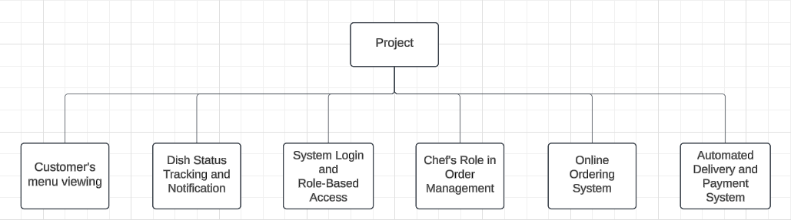

Figure 3.1

In each branch of this tree, we also have subtrees which describes the tasks needed to be accomplished of my team.

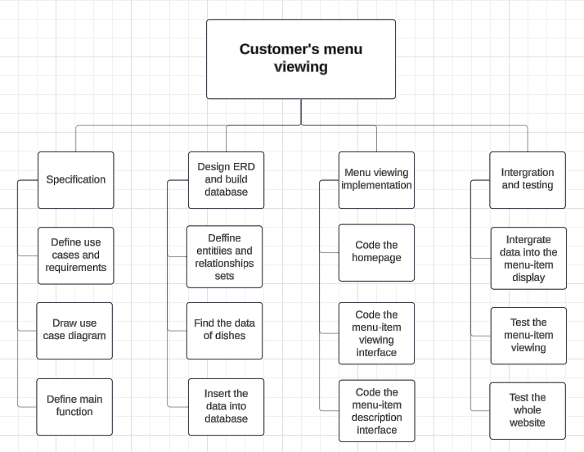The tasks for the Customer’s menu viewing is described in the ***Figure 3.2***:

Figure 3.2

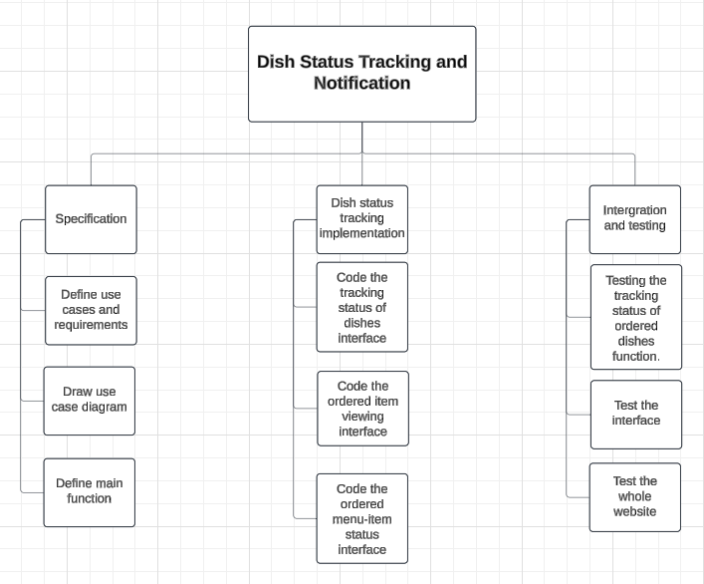The tasks for the Dish Status Tracking and Notifications is described in the ***Figure 3.3***:

Figure 3.3

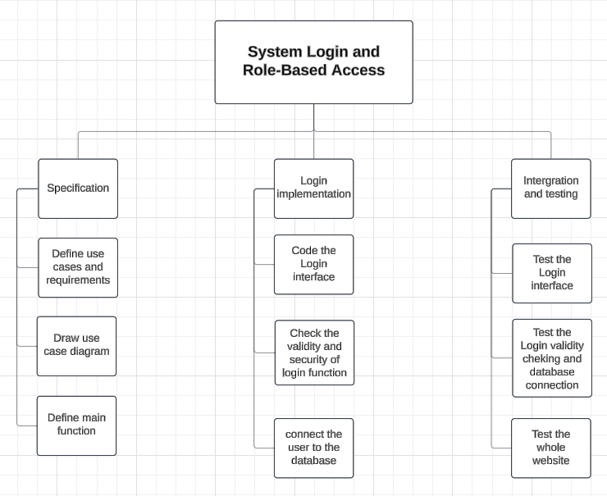The tasks for the System Login is described in the ***Figure 3.4***:

Figure 3.4

The tasks for the Managing Order of Chef’s role is described in the ***Figure 3.5***:

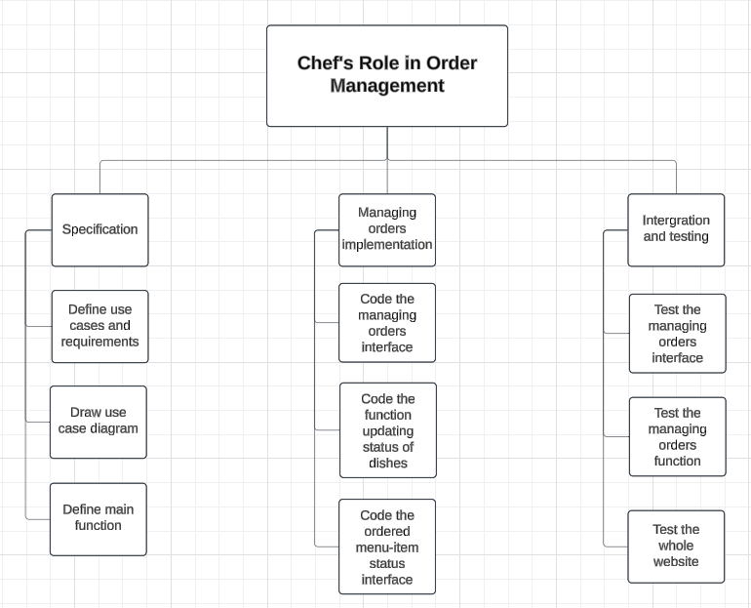

Figure 3.5

The tasks for the Online Ordering System is described in the ***Figure 3.6***:

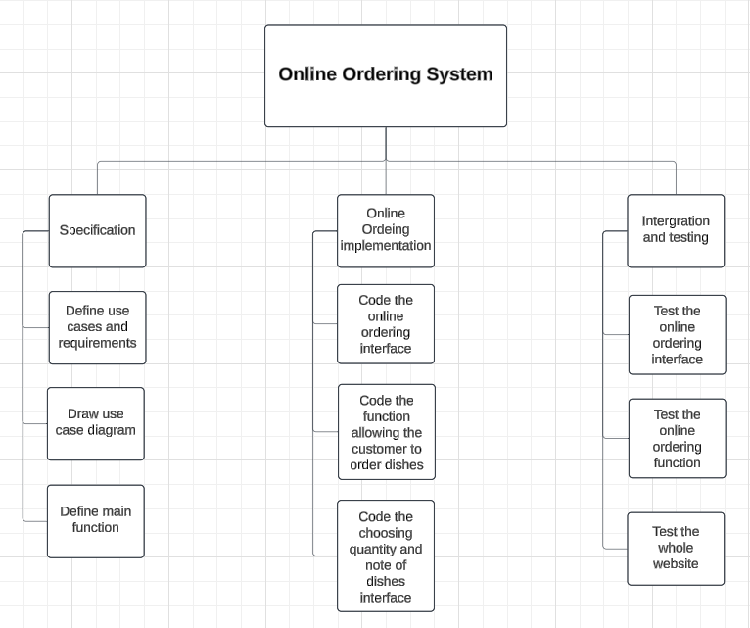

Figure 3.6

The tasks for the Payment System is described in the ***Figure 3.7***:

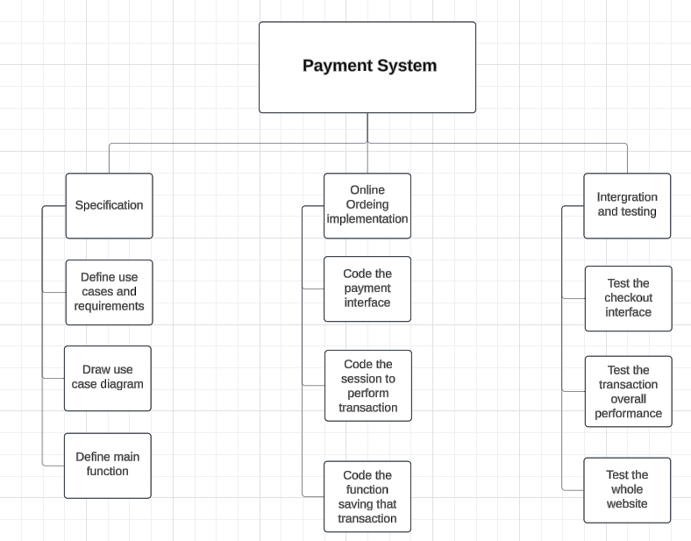

Figure 3.7

These tasks are anticipated to be completed and fully tested after each iteration of the development process, as we are adopting the agile methodology instead of the traditional approach, which separates the steps.

* 1. **DEVELOPMENT PROCESS**

Our team has decided to adopt the agile methodology for our project, specifically using the Scrum framework to guide us toward the successful completion of the project.

We anticipate that our requirements will evolve, and we aim to develop the product incrementally, addressing each functionality requested by the customers.

After every iteration, the product will be enhanced with additional features and a more user-friendly interface, enabling users to interact with the system effectively and meet their needs.

Our method can be described in the ***Figure 4.1***:

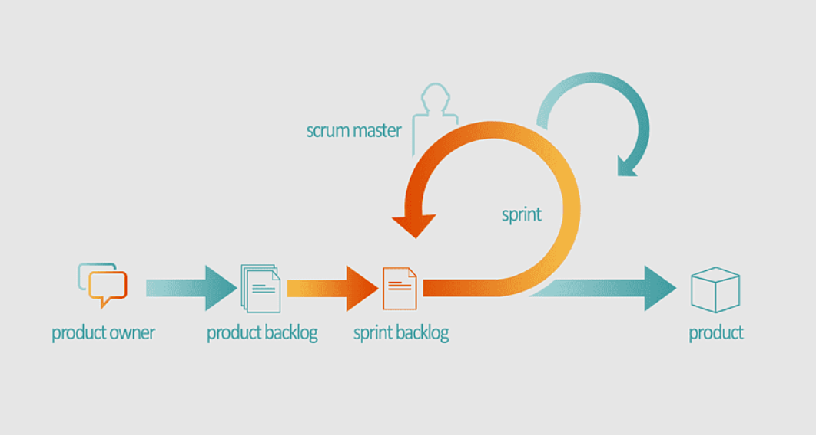

Figure 4.1

* 1. **DEVELOPMENT ENVIRONMENT**

Since this is a web-based product, the project is conducted using some Web Design and Programming Language under the model of MVC.

The following Programming Languages are used within our system:

1. **HTML:** to create an outline of the webpages
2. **CSS:** to design the looks of the webpages
3. **JavaScript:** to create animations for the webpages
4. **ReactJS:** to create form to perform transactions of the customers
5. **NodeJS:** to manipulate the data from the form to create dynamic webpages
6. **MySQL:** to store the database of the system

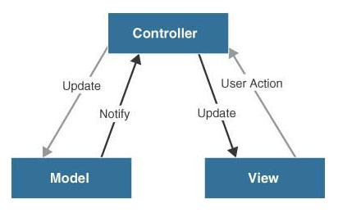The code are implemented according to the MVC model in the ***Figure 5.1***:

Figure 5.1

1. ***Model:*** the data of the system stored in the database and external system.
2. ***View:*** the user interface.
3. ***Control:*** the logic and algorithms used to develop a dynamic website with required functionalities.

In addition, our group leveraged cloud-based tools like Google Docs to streamline collaboration and seamlessly integrate contributions from all team members. We also utilized Microsoft Project, a project management tool, to monitor overall progress and evaluate each member's individual performance.

# REQUIREMENT ANALYSIS AND DESIGN

This section provides a concise overview of the requirement analysis and design process, serving as a foundation for the future implementation of the project. Using this requirements specification as a guide, we will develop each feature while ensuring all specified conditions, along with both functional and non-functional requirements provided by the customers, are met. Throughout the implementation phase, we will continuously review and refine the system to ensure progress is effectively tracked and the project remains aligned with its objectives.

* 1. **REQUIREMENT ANALYSIS**

**USE CASE DIAGRAM**

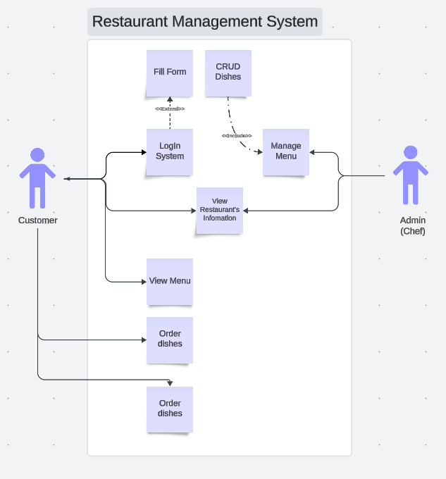

**Use Case 1: : Manage Menu**

**Name: Manage Menu**

**Identifier** *UC1*

**Inputs:**

1. Dish name, price, type of dish, serving time.

**Outputs:**

1. Updated list of menu items.

**Basic Course**

|  |  |
| --- | --- |
| Actor: Admin | System |
| 1. Admin logs into the system. |  |
| 2. Admin selects the Manage Menu function. |  |
| 3. The system displays the current menu items |  |
| 1. Admin performs the following actions | * 1. Add a new dish.   2. Edit dish information (price, type, serving time).   3. Delete a dish from the menu. |
| 1. The system updates the menu and displays a success message |  |

**Precondition**

Admin is logged into the system

**Post condition**

The menu is updated and stored in the system

**User story:**

* **As an Admin**, I want to manage the menu so that I can add, edit, or delete dishes to ensure the menu is accurate and up to date.
* **As an Admin**, I want to categorize dishes by type so that customers can browse the menu more efficiently.
* **As an Admin**, I want to update the serving time of dishes so that customers know when a dish is available.

**Use Case 2: Track Orders**

**Name: Track Orders**

**Identifier** *UC2*

**Input:**

1. Order status (Pending, In Progress, Completed).

**Outputs:**

1. Updated order status and a list of bills.

**Basic Course**

|  |  |
| --- | --- |
| Actor: Admin | System |
| 1. Admin logs into the system. |  |
| 2. Admin selects the **Food Track** function |  |
| 3. The system displays the list of ordered dishes |  |
| 4. Admin can update the status of each dish: | 4.1 Pending (waiting to be processed).  4.2 In Progress (currently being prepared).  4.3 Completed (served to the customer). |
| 5. The system saves status updates and displays a successful message. |  |

**Preconditions**

1. The system has at least one order from customers.

**Post condition**

1. The status of the ordered dishes is updated

**User Story:**

* **As an Admin**, I want to manage the menu so that I can add, edit, or delete dishes to ensure the menu is accurate and up to date.
* **As an Admin**, I want to categorize dishes by type so that customers can browse the menu more efficiently.
* **As an Admin**, I want to update the serving time of dishes so that customers know when a dish is available.

**Use Case 3: Login**

**Name: Login**

**Identifier** *UC3*

**Input:** Username and password.

**Outputs:**

1. Sign in again [If fail]
2. Access the system with decentralization [If successful]

**Basic Course**

|  |  |
| --- | --- |
| Actor: Admin, Customer | System |
| 1. Navigates to the login page. | 1.1 Login form |
| 2. Enters their username and password. |  |
| 3. The system validates the credentials. |  |
| 4. If valid, user is redirected to the main page | 4.1 Success notification |
| 1. Decentralization | 5.1 Access to each role system |

**Precondition**: Admin has a registered account in the system.

**Post condition:** Admin successfully accesses the system.

**User Story:**

* **As an Admin**, I want to log in to the system so that I can access the Admin dashboard and manage system functionalities securely.
* **As an Admin**, I want the system to validate my credentials so that unauthorized users cannot access the Admin functions.
* **As a Customer**, I want to log in to the system so that I can access features like ordering and viewing the menu.
* **As a Customer**, I want to reset my password if I forget it so that I can regain access to my account.

**Use Case 4: View Menu**

**Name: View Menu**

**Identifier** *UC4*

**Inputs:** None

**Output:** A list of menu items is displayed.

**Basic Course**

|  |  |
| --- | --- |
| Actor: Customer | System |
| 1. Customer selects the View Menu function. |  |
| 1. The system displays the menu with details (name, price, type, and serving time). |  |
| 1. The Customer can browse the menu and decide on dishes to order. |  |

**Precondition:**  Customer has completed the survey.

**Post condition**: The menu is displayed to the Customer.

**User story:**

* **As a Customer**, I want to view the menu so that I can explore the available dishes.
* **As a Customer**, I want to see detailed information about each dish (e.g., name, price, type, and serving time) so that I can make informed choices.
* **As a Customer**, I want the menu to be categorized by type (e.g., Appetizers, Main Dishes, Desserts) so that I can navigate it more easily.

**Use Case 5: Order Food**

**Name: Order Food**

**Identifier** *UC5*

**Input:** List of dishes and their quantities.

**Outputs:** Dishes are added to the order list.

**Basic Course**

|  |  |
| --- | --- |
| Actor: Customer | System |
| 1. Customer selects the Order Food function. |  |
| 1. The system displays the menu. |  |
| 1. The Customer selects dishes and their quantities, then clicks Add to Order. |  |
| 1. The Customer can continue adding more dishes to the order. |  |
| 1. The system saves order information. |  |

**Preconditions**: Customer has accessed the menu.

**Post condition**: The order list is updated

**User story:**

* **As a Customer**, I want to select dishes and quantities so that I can customize my order.
* **As a Customer**, I want to add multiple dishes to my order so that I can order for myself andothers in a single session.
* **As a Customer**, I want the system to display the total cost of my order so that I can track my spending while ordering.

**Use Case 6: Checkout**

**Name: Checkout**

**Identifier** *UC6*

**Input:**

1.  List of dishes ordered.

**Output:**

1. Total bill and confirmation of the payment.

**Basic Course**

|  |  |
| --- | --- |
| Actor: Customer | System |
| 1. Customer selects the **Checkout** function. |  |
| 1. The system displays the list of ordered dishes with their total price. |  |
| 1. The Customer confirms the payment. |  |
| 4. Click “Remove from Cart” of item |  |
| 5. The system saves the bill information and displays a success message. |  |

**Preconditions**

1. User has logged in
2. User is currently in the product viewing or product description page

**Post conditions**

1. Items added to or removed from the shopping cart or wish list
2. Database updated

**User Story:**

* As a Customer, I want to review the list of dishes I ordered before finalizing the payment so that I can ensure everything is correct.
* As a Customer, I want the system to calculate the total cost of my order, including any taxes or discounts, so that I know exactly how much I need to pay.
* As a Customer, I want to receive a confirmation of my payment so that I know my order has been successfully processed.

**User story 1:**

* As an Admin, I want to manage the menu so that I can add, edit, or delete dishes to ensure the menu is accurate and up to date.
* As an Admin, I want to categorize dishes by type so that customers can browse the menu more efficiently.
* As an Admin, I want to update the serving time of dishes so that customers know when a dish is available.

**User story 2:**

* As an Admin, I want to see a list of all active orders so that I can monitor the progress of food preparation.
* As an Admin, I want to update the status of an order (e.g., Pending, In Progress, Completed) so that I can communicate the progress to the customer.
* As an Admin, I want to view detailed order bills so that I can ensure all items are accounted for before finalizing the order.

**User story 3:**

* As an Admin, I want to log in to the system so that I can access the Admin dashboard and manage system functionalities securely.
* As an Admin, I want the system to validate my credentials so that unauthorized users cannot access the Admin functions.
* As a Customer, I want to log in to the system so that I can access features like ordering and viewing the menu.
* As a Customer, I want to reset my password if I forget it so that I can regain access to my account.

**User story 4:**

* As a Customer, I want to view the menu so that I can explore the available dishes.
* As a Customer, I want to see detailed information about each dish (e.g., name, price, type, and serving time) so that I can make informed choices.
* As a Customer, I want the menu to be categorized by type (e.g., Appetizers, Main Dishes, Desserts) so that I can navigate it more easily.

**User story 5:**

* As a Customer, I want to select dishes and quantities so that I can customize my order.
* As a Customer, I want to add multiple dishes to my order so that I can order for myself and others in a single session.
* As a Customer, I want the system to display the total cost of my order so that I can track my spending while ordering.

**User story 6:**

* As a Customer, I want to review the list of dishes I ordered before finalizing the payment so that I can ensure everything is correct.
* As a Customer, I want the system to calculate the total cost of my order, including any taxes or discounts, so that I know exactly how much I need to pay.
* As a Customer, I want to receive a confirmation of my payment so that I know my order has been successfully processed.

1. **FUNCTIONAL REQUIREMENTS**

## Use Case 1: Manage Menu

* 1. ***The Scope of the Work***
     + Occurs in Sprint 2.
     + 6 tasks required for this function.
     + 30 hours of effort estimated.
  2. ***The Scope of the Product***:
     + Shall display the current menu items with details (name, price, type, and serving time).
     + Shall allow the admin to add a new dish with specified attributes (name, price, type, serving time).
     + Shall allow the admin to edit the details of an existing dish.
     + Shall allow the admin to delete a dish from the menu.
     + Shall update and store the menu changes in the database.
     + Shall display a success or error message after each action.
  3. ***Data Requirements***
* Valid dish details (non-empty name, price as a positive number, valid type, and serving time format

## Use Case 2: Track Order

* 1. ***The Scope of the Work***
     + Occurs in Sprint 3.
     + 5 tasks required for this function.
     + 25 hours of effort estimated.

1. ***The Scope of the Product***:
   * + Shall display the list of all active orders with their status (Pending, In Progress, Completed).
     + Shall allow the admin to update the status of an order.
     + Shall validate the selected status before saving (e.g., no invalid transitions).
     + Shall save the updated order status in the database.
     + Shall display a success message after updating the order status.
2. ***Data Requirements***
   * + Valid order data exists in the database.
     + Status changes adhere to logical transitions (e.g., cannot skip directly from Pending to Completed).

## Use Case 3: Login

1. ***The Scope of the Work***
   * + Occurs in Sprint 1.
     + 4 tasks required for this function.
     + 20 hours of effort estimated.
2. ***The Scope of the Product***: This is the main part of user’s login functionality
   * + Shall display a login form for the user to input their credentials.
     + Shall validate the entered username and password against the database.
     + Shall allow access based on user role (Admin or Customer).
     + Shall display error messages for invalid login attempts.
     + Shall log failed login attempts for security purposes.
3. ***Data Requirements***
   * + Valid username and password stored in the database.
     + Passwords must be encrypted in the database.

## Use Case 4: View Menu

## The Scope of the Work

* + - Occurs in Sprint 2.
    - 3 tasks required for this function.
    - 15 hours of effort estimated.

1. ***The Scope of the Product***:
   * + Shall display the menu items with details (name, price, type, and serving time).
     + Shall categorize menu items for easy navigation (e.g., Appetizers, Main Dishes, Desserts).
     + Shall allow customers to filter the menu by category or availability.
2. ***Data Requirements***
   * + The menu must contain at least one dish.
     + Each dish has valid details (name, price, type, and serving time).

## Use Case 5: Order Food

## The Scope of the Work

* + - Occurs in Sprint 3.
    - 4 tasks required for this function.
    - 20 hours of effort estimated.

1. ***The Scope of the Product***:
   * + Shall allow customers to select dishes and specify quantities.
     + Shall add selected dishes to the order list.
     + Shall calculate and display the total cost of the order.
     + Shall allow customers to modify the order (add/remove items).
     + Shall save the final order information in the database.
2. ***Data Requirements***
   * + Valid menu data exists in the database.
     + Quantity must be a positive integer.

## Use Case 5: Checkout

## The Scope of the Work

* + - Occurs in Sprint 4.
    - 5 tasks required for this function.
    - 25 hours of effort estimated.

1. ***The Scope of the Product***:
   * + Shall display the list of ordered dishes with their total cost.
     + Shall allow customers to remove items from the order list during checkout.
     + Shall calculate the total cost, including taxes and discounts, if applicable.
     + Shall save payment information and order status in the database.
     + Shall display a confirmation message after successful payment.
2. ***Data Requirements***
   * + Valid order information (dish list, quantities, and prices).
     + Payment details must be valid and processed securely.

1. **NON-FUNCTIONAL REQUIREMENTS**

## Operational requirements:

* + - The system must ensure all components function smoothly and efficiently under normal and peak load conditions.
    - The hosting environment must be capable of managing and handling all user requests, including scalability for future growth.
    - The software must be regularly updated by an administrator, and a maintenance plan should be in place for monitoring system performance and handling errors promptly.

## Usability requirements:

* + - The system must be intuitive and easy to use for both administrators and customers, minimizing the need for extensive training.
    - User interfaces should be responsive and easy to navigate, with clear, actionable error messages that guide users to resolve issues.
    - Comprehensive user manuals and help documentation must be provided to assist users in navigating the system.
    - The system should be compatible with various devices and screen sizes, offering an optimal experience on both mobile and desktop platforms.
    - The user experience should be optimized to ensure that actions, such as ordering or checkout, can be completed with minimal steps and errors.

## Performance Requirements:

1. ***Response Requirements***
   * + - * Login response time should be under 2 seconds for both administrators and customers to ensure quick access.
         * System updates to the database, such as adding or removing menu items or processing orders, should take less than 1 second for seamless operations.
         * The system should be able to process at least 10 transactions concurrently without any significant performance degradation.
         * Page loading times must be under 3 seconds, even when displaying large amounts of content like product listings.
2. ***Throughput Requirements*** (how much can system achieved in a specific amount of time)
   * + - * The system must handle more than 1,000 simultaneous customer visits without any slowdown or delays, ensuring customers can browse the site smoothly.
         * The database should be capable of handling high frequency read/write operations (e.g., 100+ queries per second) to accommodate many transactions.
3. ***Availability Requirements*** (is the system available when is requested by the user)
   * + - * The system should be available 99.9% of the time, with downtime limited to scheduled maintenance periods. In case of failure, recovery time should be within 10 minutes.
         * Memory and resource management must be optimized to prevent system crashes or slowdowns under heavy traffic conditions.

## Description:

The system must be able to manage heavy user traffic (over 1,000 visitors simultaneously) and process large volumes of data, such as orders and inventory updates, in real time without performance issues.

## Maintainability Requirements:

* + - * + The system must be built in a modular and maintainable manner, with clear and well-documented code that enables easy updates, bug fixes, and future enhancements.
        + It should include an admin interface for easy management of products, customers, and order information, as well as functions for updating content without deep technical knowledge.
        + The database schema must be clear, stable, and easily extendable to accommodate future system changes without major redesign.

## Support Requirements

* + - * + Support mechanisms, including live chat, email support, or helpdesk, must be available for administrators and customers to resolve issues quickly.
        + A dedicated hotline and remote troubleshooting tools (e.g., TeamViewer) should be provided for quick resolution of critical system issues.
        + Routine system checks and maintenance must be carried out periodically (monthly or quarterly) to ensure optimal performance.

## 

## Security requirements:

* + - * + The system must ensure user data is encrypted both at rest and in transit, using protocols like SSL/TLS for communication and AES for data storage.
        + User authentication should include secure login methods, such as two-factor authentication (2FA) for administrators, and password hashing for secure storage.
        + Data access permissions should be role-based, with strict controls ensuring that only authorized personnel can modify critical system data (e.g., admin-level access).
        + The system should log all critical events (logins, order updates, payment processing) with timestamp, user, and action details to ensure traceability.
        + Backup of all system data, including orders and customer information, should be conducted daily, with a secure off-site backup to mitigate data loss risks.
        + The system should comply with data privacy regulations such as GDPR, ensuring that customer information is not shared without explicit consent.

## Interface requirements:

* + - * + The system should use standardized protocols (e.g., RESTful APIs) for integration with other systems (payment gateways, inventory management, etc.).
        + User interface components (buttons, forms) should have clear labels and symbols that match their functionality to prevent confusion.
        + The system should support multiple languages and localizations, allowing international customers to view content in their preferred language.
        + The system must include a system for handling errors gracefully, including informative error messages and retry mechanisms for failed transactions.
  1. **DESIGN**

System Architecture Model

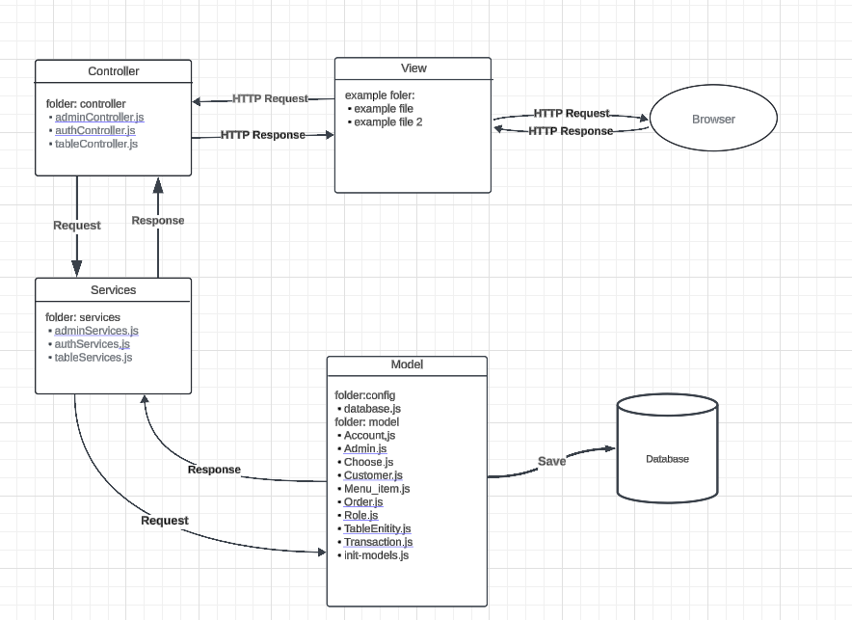

**Entity-Relationship Diagram (ERD)**

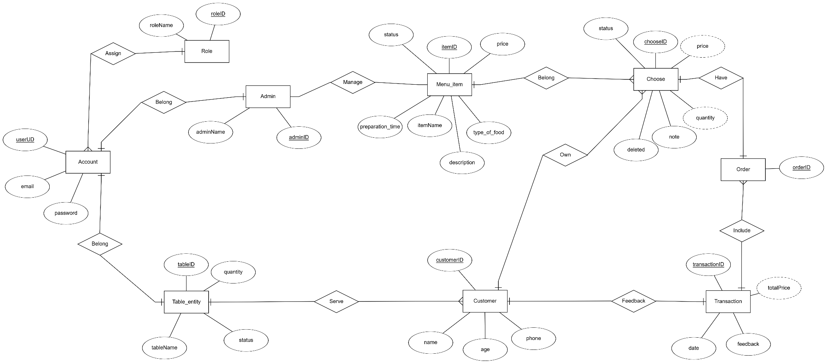

**Schema Diagram**

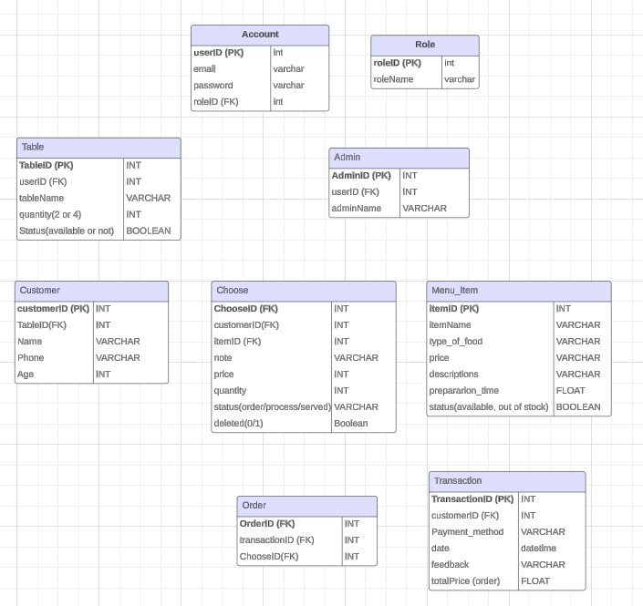

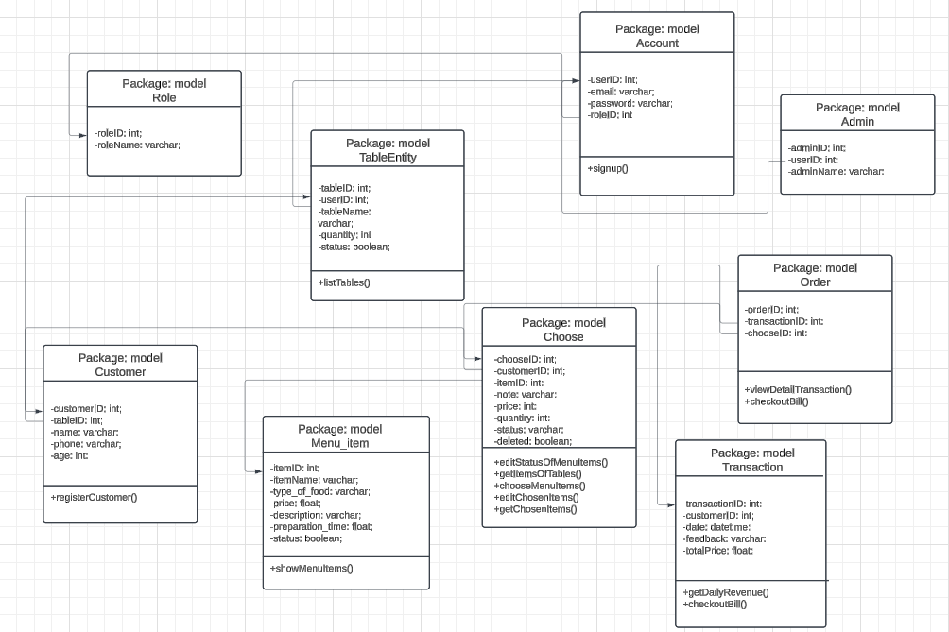**Class Diagram**

**Use Case Diagram**



**Use Case 1: Log in the store system**

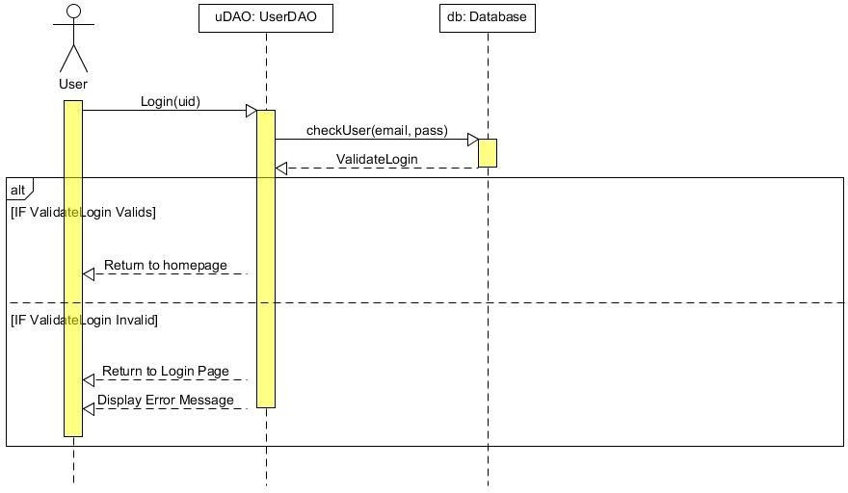

**Use Case 2: Create a new store account**

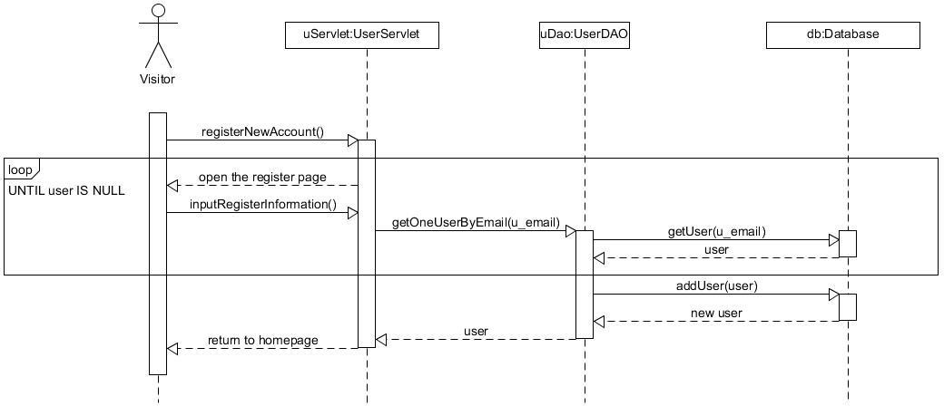

**Use Case 3: Comment and Discussion about the products**

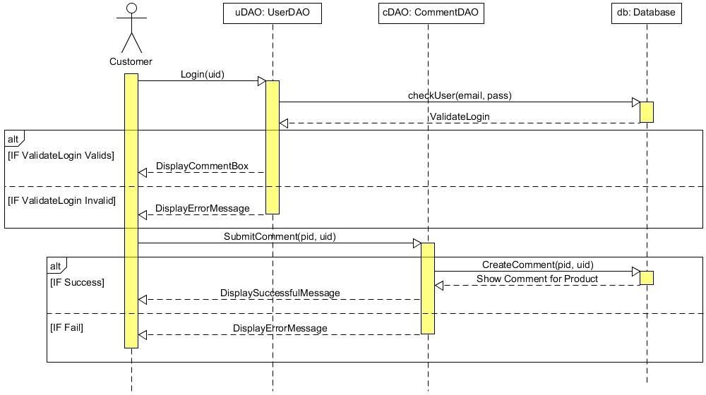

**Use Case 4: Rate/Vote the quality of products**

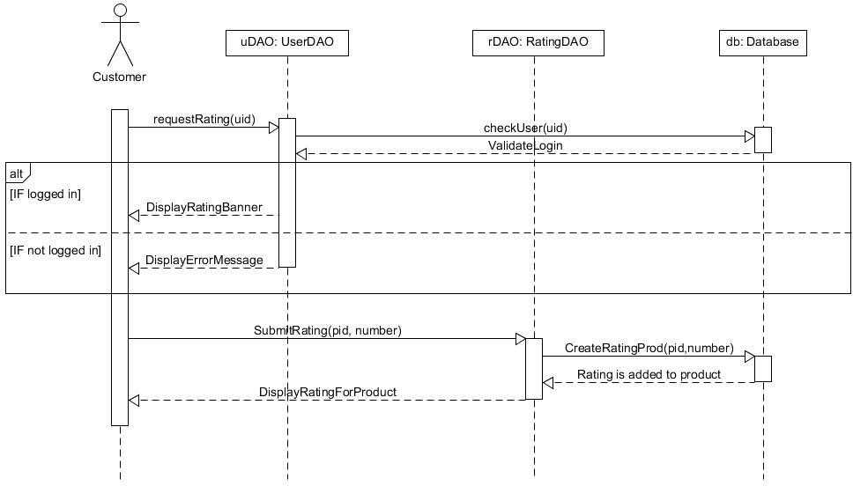

**Use Case 5: Search the product by name, price, category, functionalities**

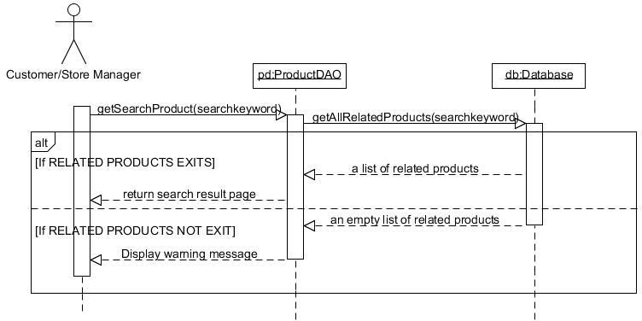

**Use Case 6: Add/ Remove desired products to/from wish list and shopping cart**

***Use Case 6.1: Add to wish list***

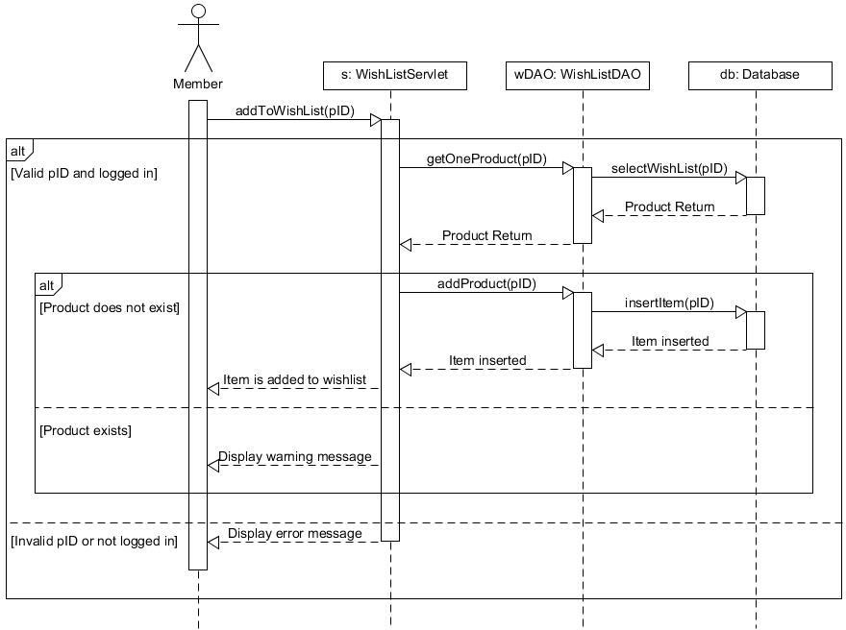

***Use Case 6.2: Remove from wish list***

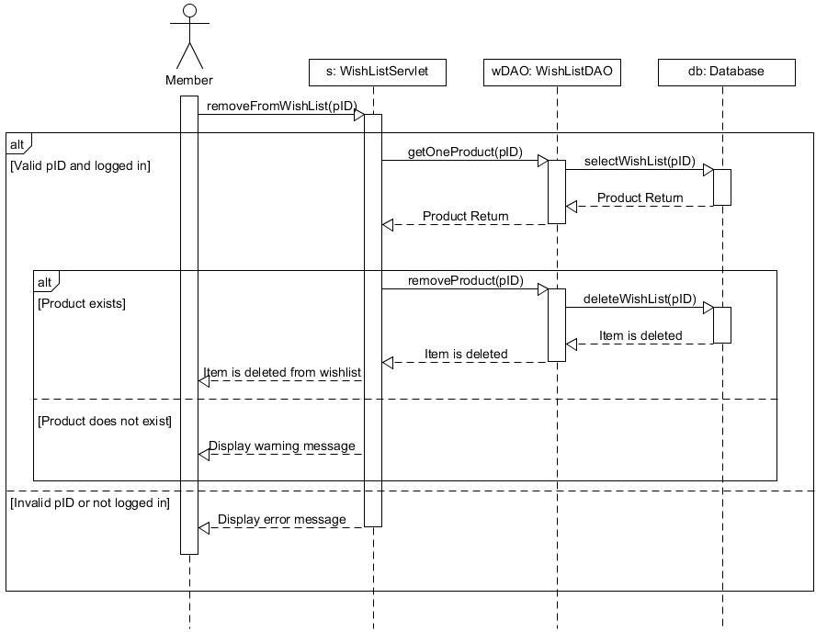

***Use Case 6.3: Add to shopping cart***

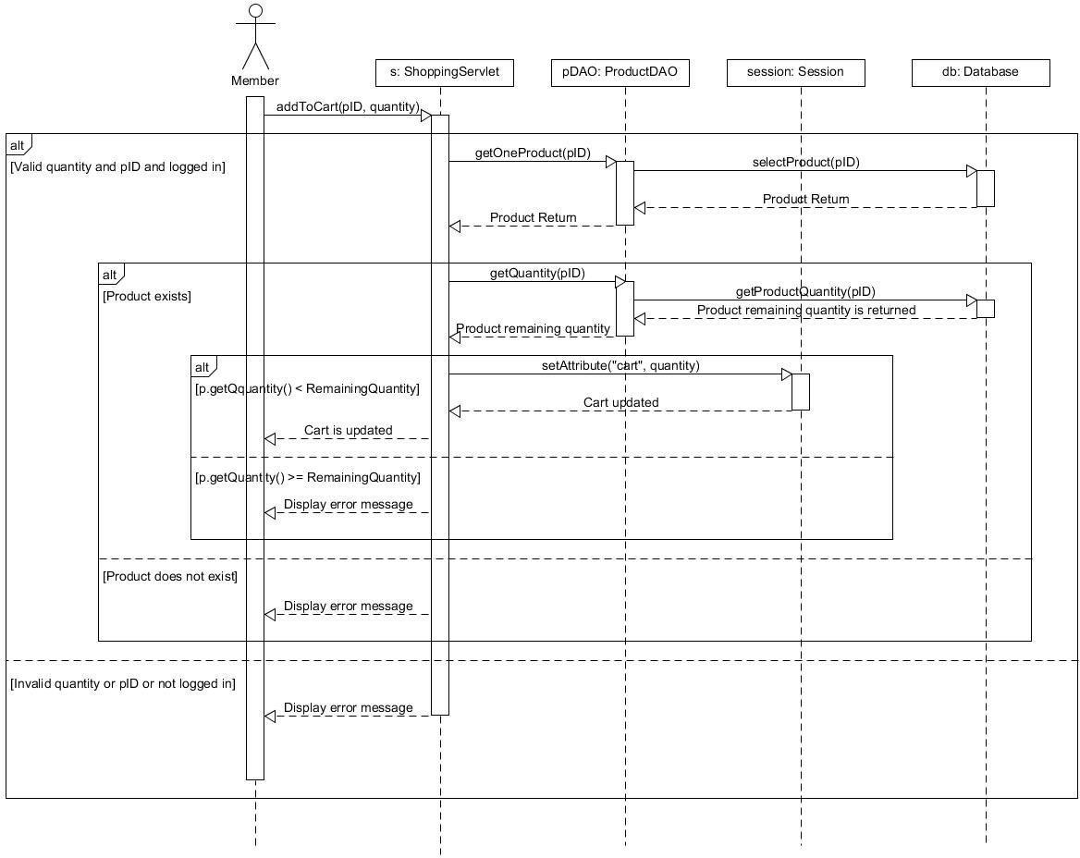

***Use Case 6.4: Remove from shopping cart***

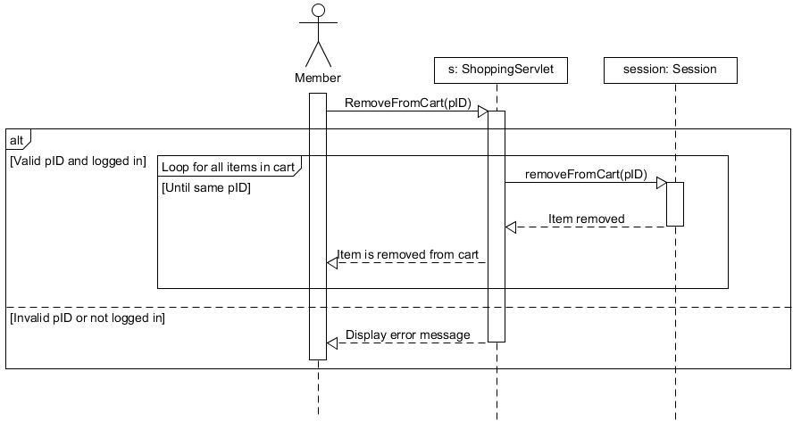

**Use Case 7: Perform buying transaction and checkout**

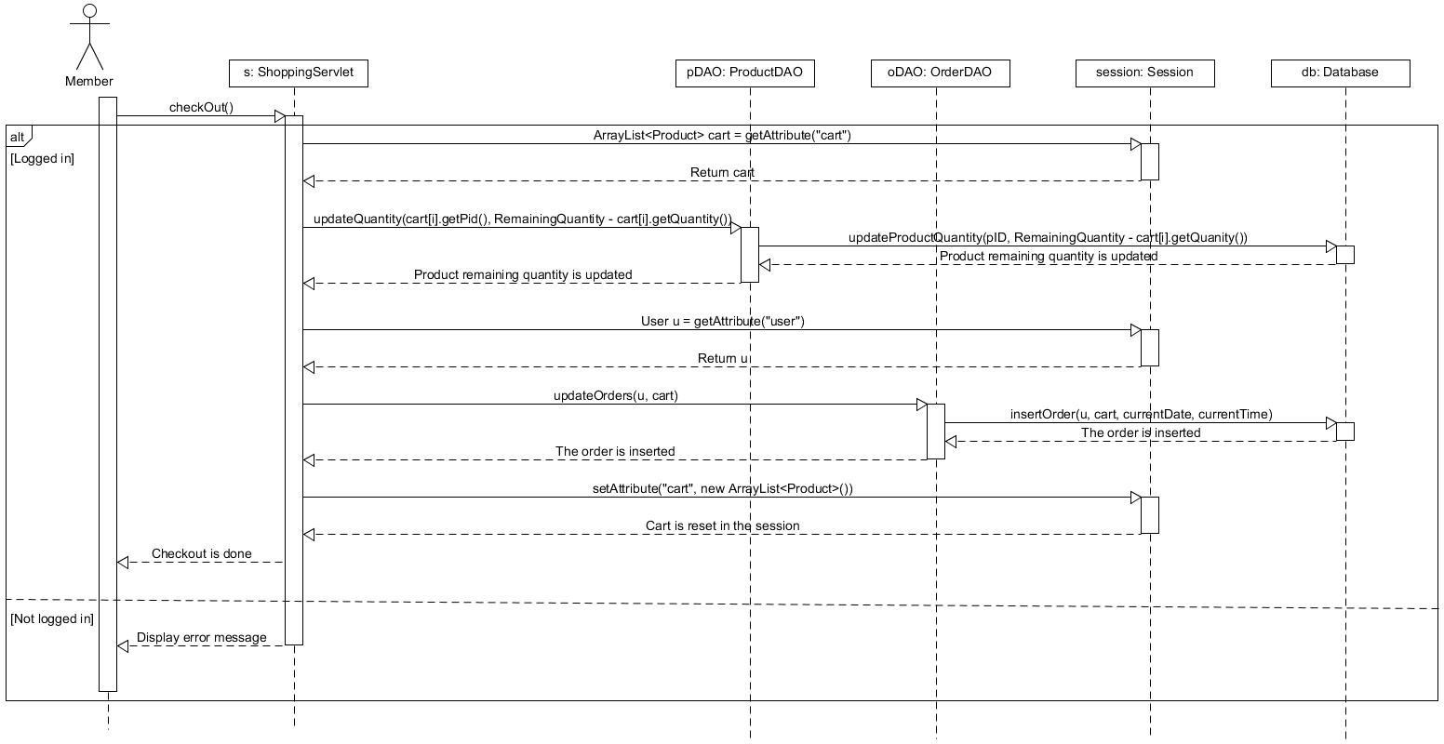

**Use case 8: Get the purchase receipt via email**

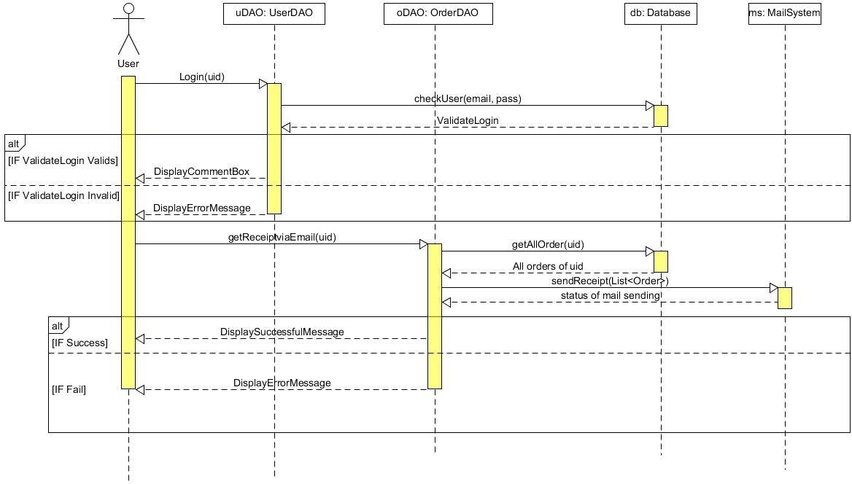

**Use Case 9: Display user’s profile**

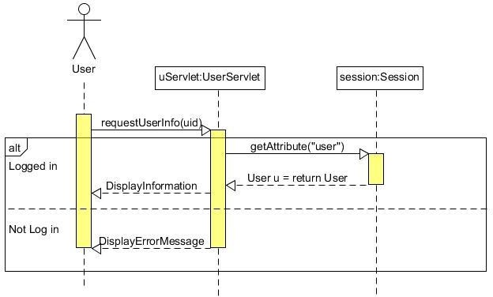

**Use Case 10: Check availability of merchandise, Update the product information and clearance sale-off**

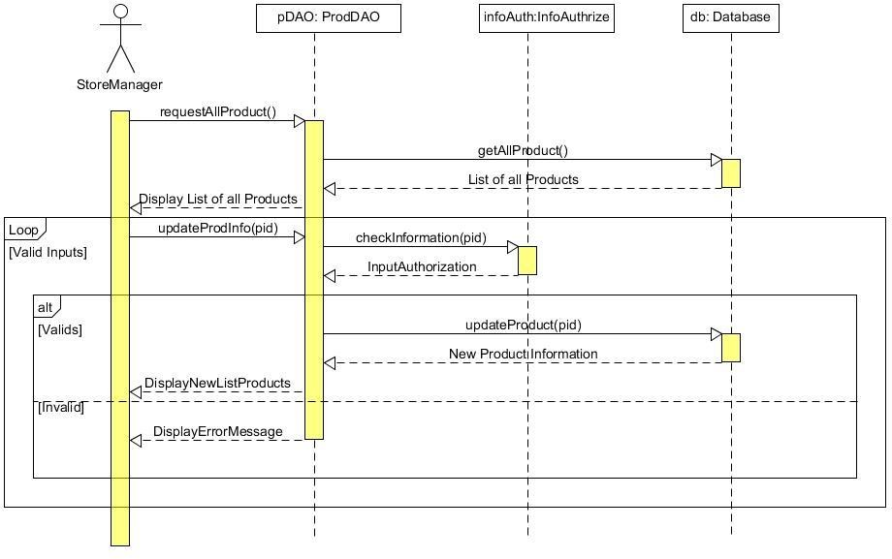

**Use Case 11: Generate reports of sales after each day/month/quarter/year and customers’ interests**

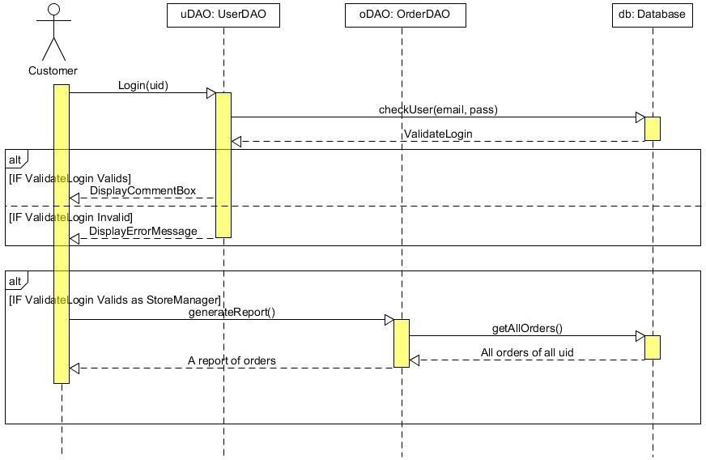

**Use Case 12: View the product’s information on the web page (for visitor)**

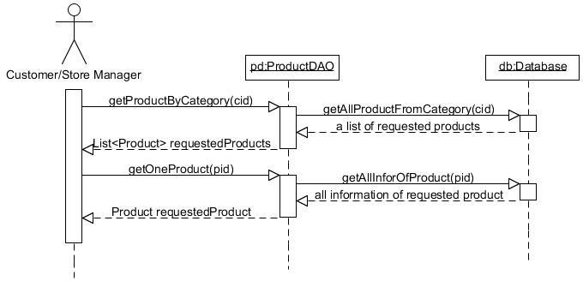

# III. IMPLEMENTATION

**3.1. GENERAL PAGES:**

**3.1.1 Welcome page:**

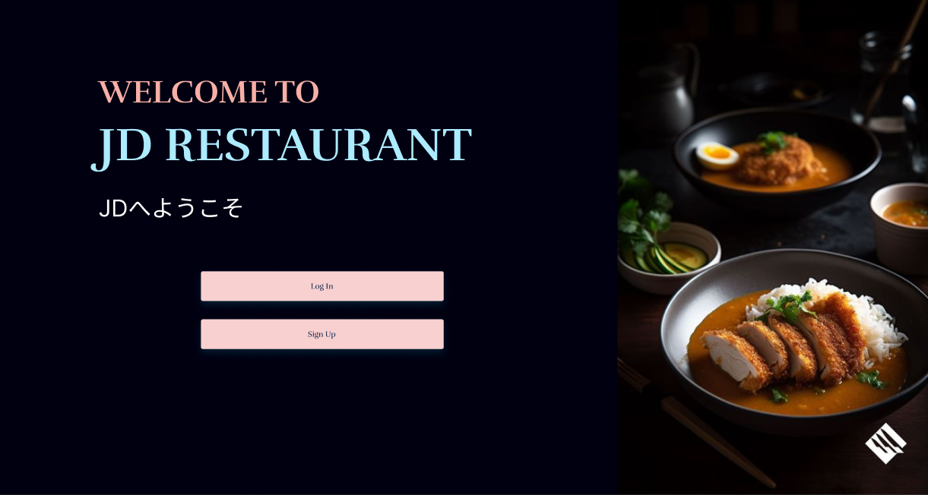

The welcome page serves as the initial interface that users encounter upon accessing the website. This page acts as a gateway, providing users with navigation options to proceed to either the login or sign-up pages. It is designed to accommodate both roles—admin and customer—ensuring a unified entry point for all users. The layout and design of the welcome page prioritize simplicity and clarity, facilitating a seamless transition to authentication processes for both roles.

**3.1.2 Log-in page:**

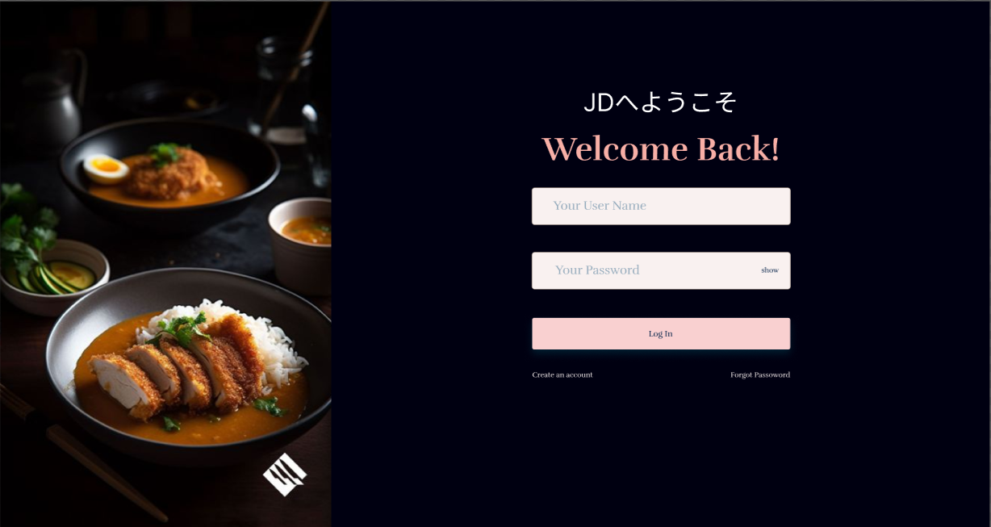

The login page enables users to authenticate their accounts by providing their email and password.

The process is implemented as follows:

1. Input Fields:
   * Users are required to enter their registered email address and password into the respective input fields.
2. Authentication Process:
   * Upon submission, the system retrieves the stored hashed password associated with the provided email address from the database.
3. Password Verification:
   * The system uses the bcrypt.compare() function to securely compare the plaintext password entered by the user with the hashed password stored in the database.
   * The bcrypt.compare() function evaluates the match and returns a boolean value:
     + True indicates the passwords match, and the user is authenticated.
     + False indicates the passwords do not match, and the login is denied.
4. Successful Authentication:
   * If the credentials are valid, the user is granted access to other pages based on their role (Customer or Admin/Chef).
5. Error Handling:
   * If authentication fails (e.g., incorrect email or password), an appropriate error message is displayed to the user, prompting them to re-enter valid credentials.

**3.1.3 Sign-up page:**

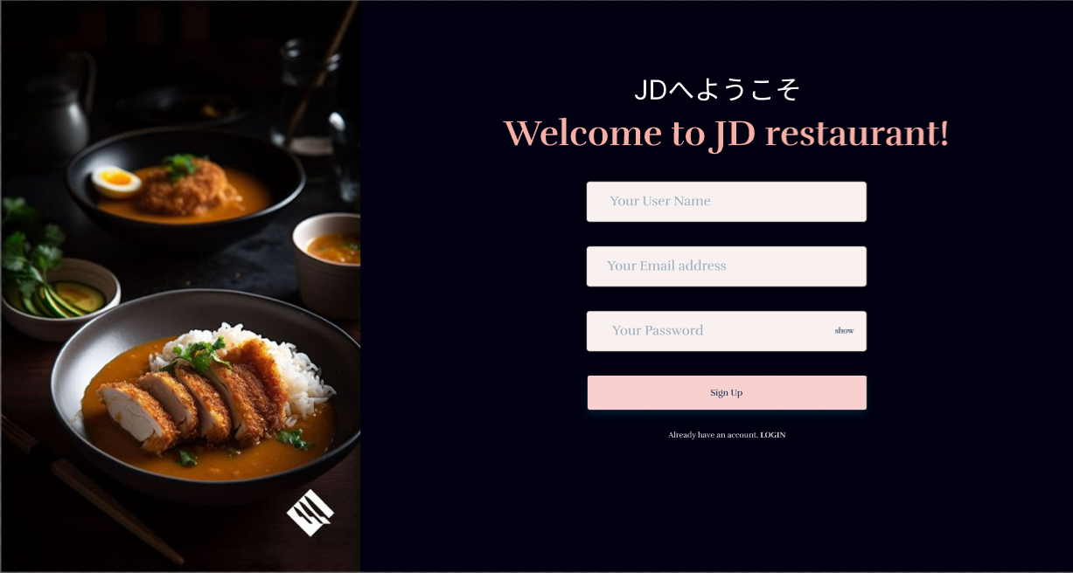

The sign-up page allows users to create a new account in the system.

The process for user registration is outlined as follows:

1. Input Fields:
   * The user is required to provide a username, email address, and password through the designated input fields on the sign-up form.
2. Password Hashing:
   * To enhance security, the provided plaintext password is processed using the bcrypt.hash() function before being stored in the database.
   * The bcrypt.hash() function operates as follows:
     + It takes the plaintext password and a salt factor (a value that increases the complexity of the hash) as parameters input.
     + The function generates a hashed version of the password asynchronously, ensuring the original password is not stored in the database.
3. Database Storage:
   * Once the password is hashed, the system stores the user's information—username, email, and hashed password—in the database.
4. Account Creation Confirmation:
   * Upon successful registration, the user receives a confirmation message or is redirected to the login page to access their account.
5. Error Handling:
   * If the email is already registered or any field is left blank, the system prevents account creation and displays an error message prompting the user to resolve the issue.

**3.2. CUSTOMER ROLE PAGES**

**3.2.1 Information pages:**

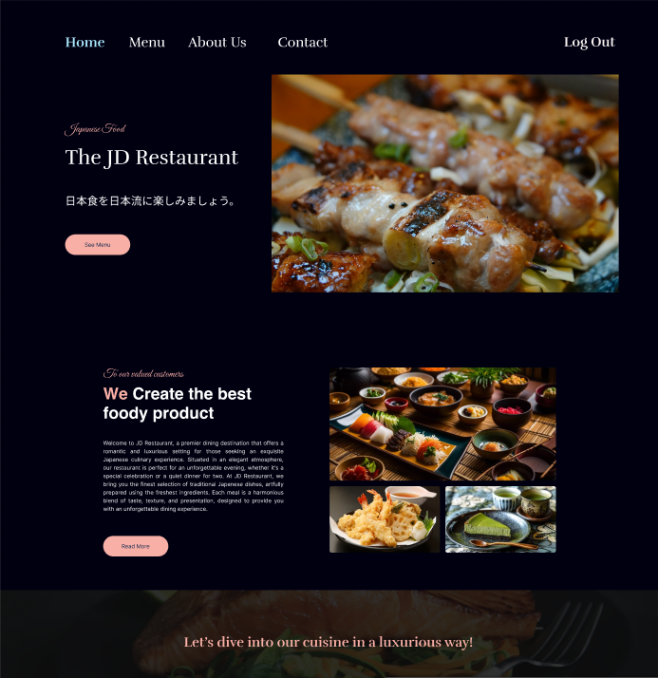

Home Page

The home page serves as the central hub of the website, providing users with an overview of the restaurant’s offerings and key navigation links.

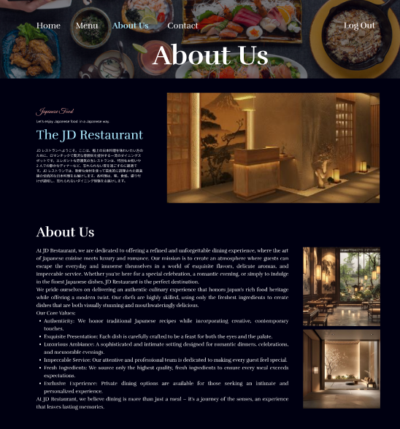

About Us Page

The "About Us" page provides detailed information about the restaurant, its history, and its mission.

**3.2.2 Menu Interfaces:**

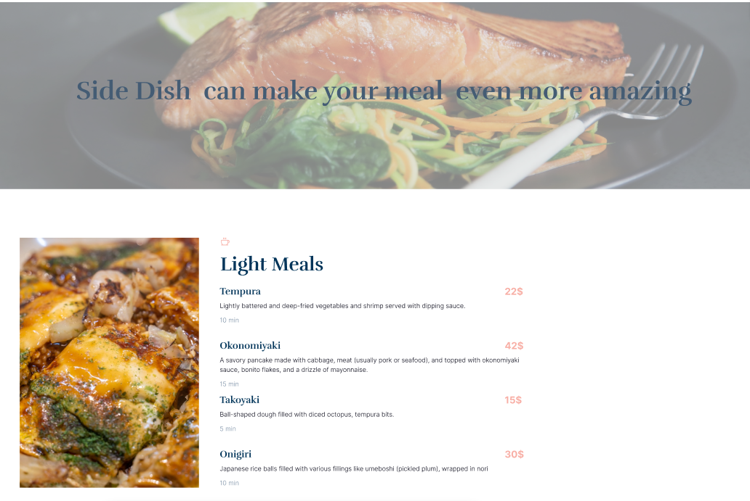

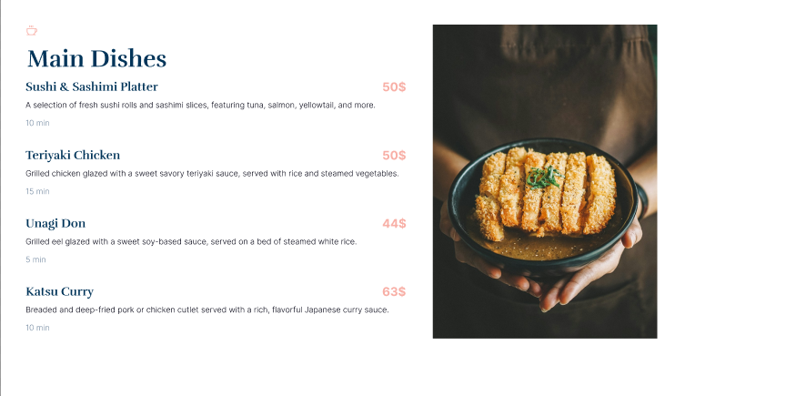

Menu Pages

The menu pages serve as a comprehensive catalog of the restaurant's offerings, allowing customers to browse dishes conveniently. The menu is structured and organized according to food categories to enhance the user experience.

**3.2.3 Ordering Interfaces from customer’s side.**

**Step 1: Filling the information of customer.**

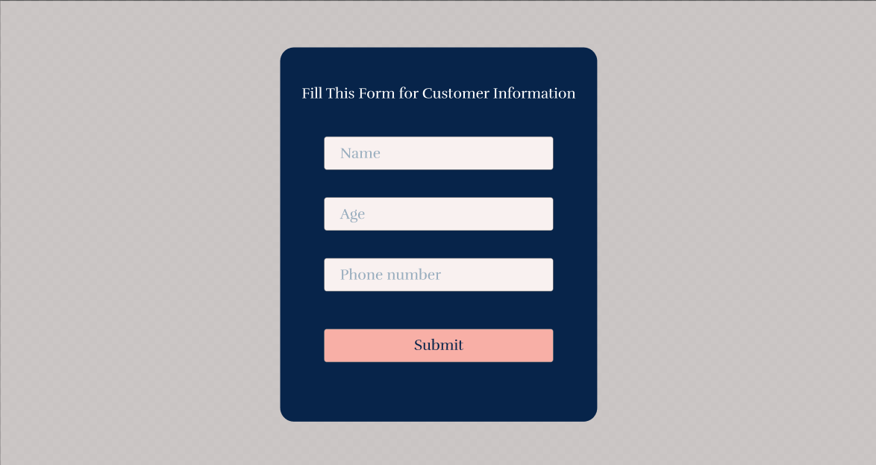

Customer Information Page

The customer information page is designed to collect essential details from users after they log in for the first time. This step ensures that a unique customer ID is created in the database, enabling them to place orders and complete transactions seamlessly.

**Step 2: Choosing the dishes from customer.**

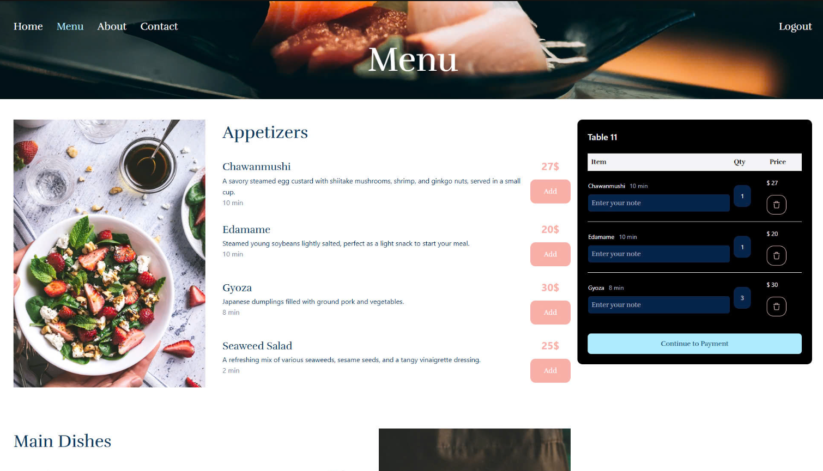

Menu Selection Page

This page allows customers to browse the restaurant's menu, select desired items along with the note for each dish, and proceed to place an order.

* Click "Continue to Payment" → Turn to *Ordering Page.*
* Click "Add" → Add the food into list of requested dishes.
* Click "Bin icon" → Remove the dish from the list.

**Step 3: Ordering the chosen dishes from the customer.**

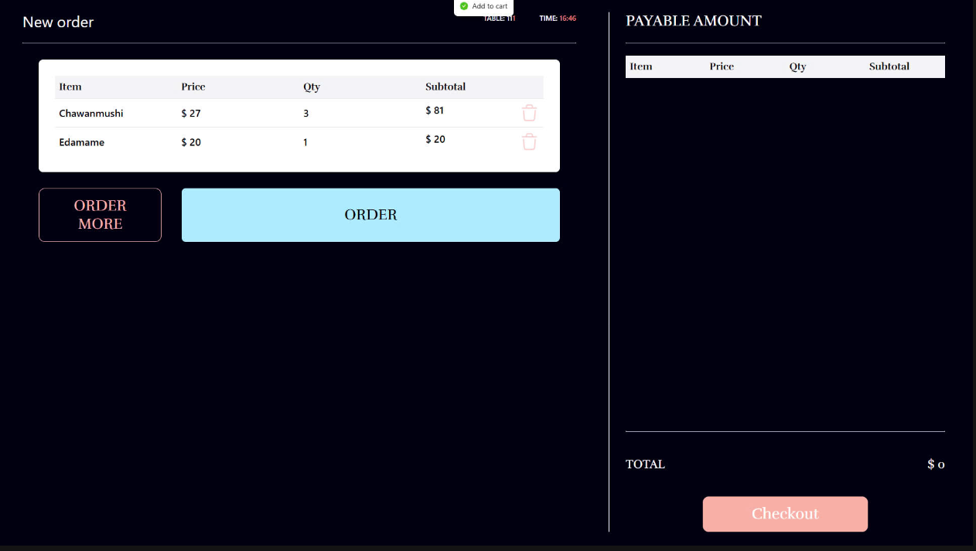

The Ordering Page

This page confirms the customer's selected dishes and allows them to either modify the order or proceed.

* Click "ORDER" → All chosen dishes will be turned to the list of ordered items and sent the order to the admin side.

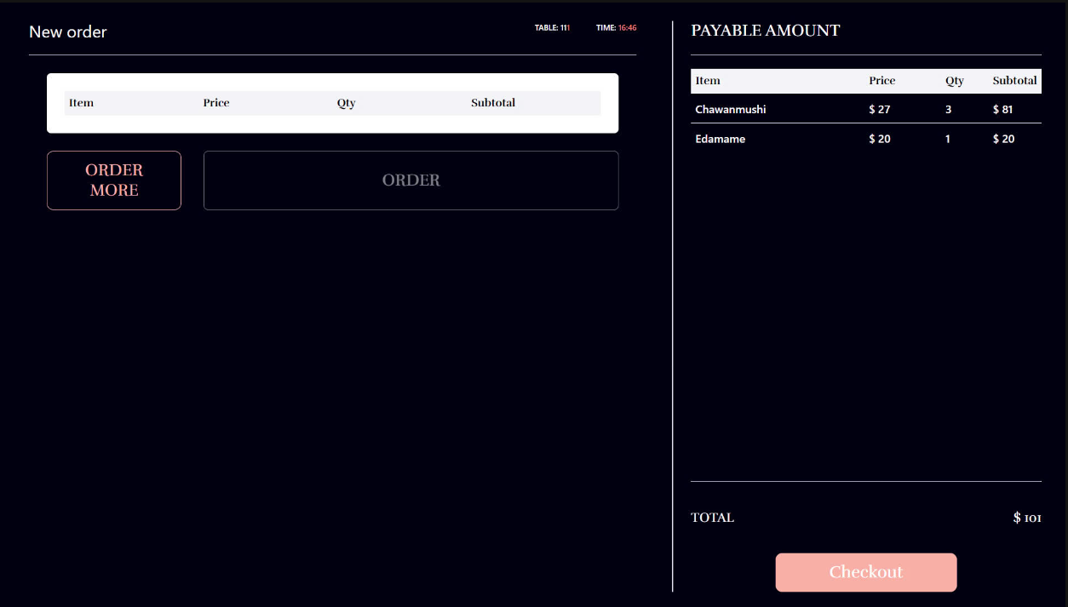

* Click "ORDER MORE" → Return to Menu Selection Page.
* Click "Checkout" → Finish the meal and create the transaction with a bill for that customer and lead the customer to Feedback Page.

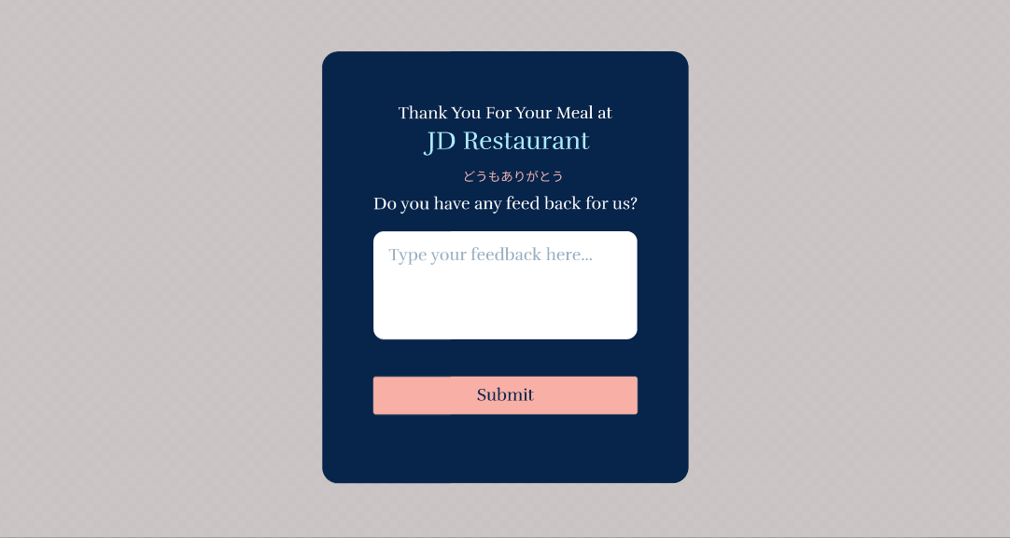

The Feedback Page

This page allows customers to provide feedback along with the transaction about their experience or the specific transaction, helping the admin gather insights to improve services.

**Step 4: Turn to the Menu Selection Page when finishing ordering the dishes.**

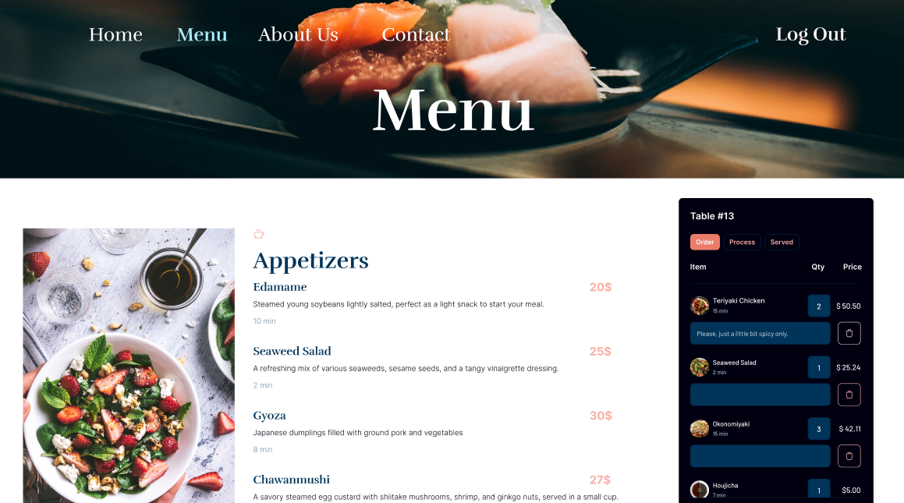

The Menu Page with Order Status

This page provides customers with a detailed view of their ordered dishes and the status of each item, ensuring transparency and real-time updates about the preparation process from the chef’s side.

**3.3. ADMIN ROLE PAGES**

**3.3.1 Menu Page.**

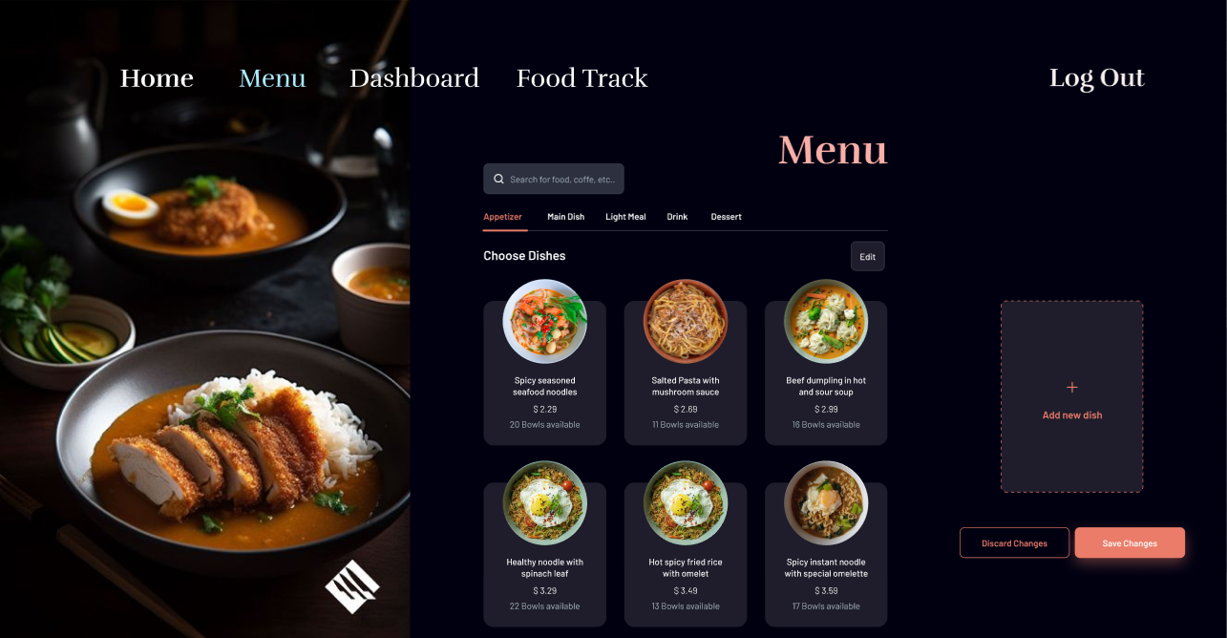

The Menu Page

This page allows the admin to manage the restaurant’s dishes, ensuring the menu is up-to-date and reflective of customer preferences.

* Click "Add new dish" → Create new dishes by entering details.
* Click "Edit" → Edit Existing Dishes including its name, price, or description.
* Click "Save Changes" → Decide to save all current changes.
* Click "Discard Changes" → Decide to discard all current changes.

**3.3.2 Dashboard Page.**

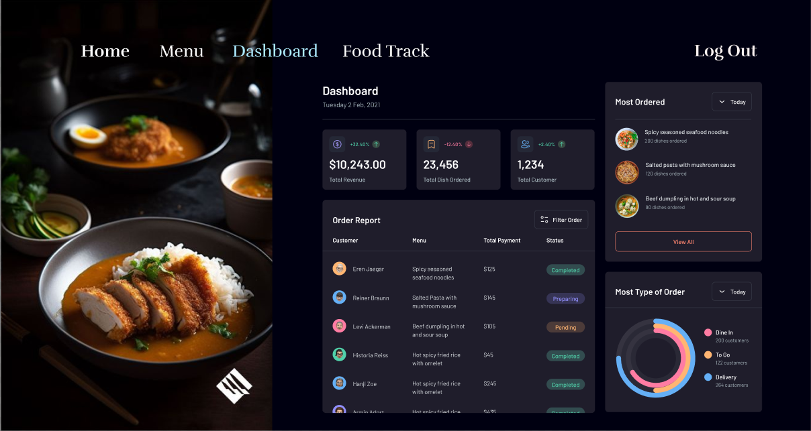

The Dashboard Page

This page provides a comprehensive overview of the restaurant’s performance and transaction data.

* Daily Revenue:
  + Displays the total income generated for the current day.
  + Option to filter revenue by date range for deeper analysis.
* Favorite Dishes:
  + It shows the most popular dishes based on customer orders, ranked by sales.
* Transaction Overview:
  + Displays of all transactions made by customers.
* Transaction Details:
  + View detailed information for each transaction, including list of ordered dishes, quantity and price of each dish, …

**3.3.3 Food Track Page.**

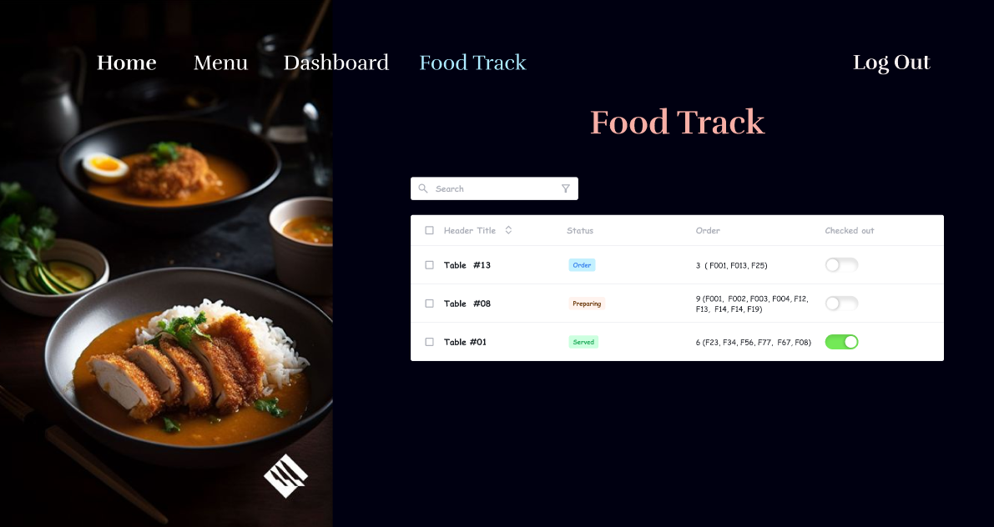

The Food Track Page

This page allows the admin to monitor and manage the status of orders from ongoing tables, ensuring efficient service.

* View all ongoing tables and their respective orders, including:
  + Table Number or ID.
  + List of dishes ordered per table.
  + Status of each dish.
* Change the status of any dish in real-time, with options:
  + Order: The order is received but not yet prepared.
  + Process: The dish is being cooked.
  + Served: The dish has been delivered to the customer.
* Reflect changes immediately on the customers’ side to keep them informed.

# IV. DISCUSSION AND CONCLUSION

The project of Smart Restaurant Management System provides valuable insights into the process of web application development and real-time system integration. As the project concludes, there are several areas for future improvement and extensions. Firstly, to enhance customer experience, the system could incorporate a more personalized approach by integrating customer preferences, such as recommending popular dishes or frequently ordered items based on past orders. This would increase customer satisfaction and boost the restaurant's efficiency. Secondly, the system could be extended to include real-time analytics for the manager, providing insights into daily trends, peak hours, and popular menu items. Lastly, for wider deployment beyond a demo environment, ensuring scalability and seamless integration with third-party payment systems is crucial to provide a smooth and secure transaction experience for customers.

Through this project, we also gained significant learning and skill development. Firstly, we enhanced our technical abilities in implementing features such as secure online ordering, real-time communication between kitchen and customer, and payment verification processes. These are key components of a functional and scalable system. Secondly, our skills in requirement analysis were sharpened, as we translated Steve's vision into a practical and efficient implementation plan. Finally, working on a project of this scale improved our teamwork and communication skills, enabling effective collaboration, task allocation, and conflict resolution within the team.

In summary, the Smart Restaurant Management System project has been a valuable opportunity to apply theoretical knowledge to practical challenges. It has allowed us to strengthen our technical expertise, refine our analytical thinking, and develop essential professional skills that will benefit us in future projects.

# V. REFERENCES

* **SCRUM**
  + https:[//www.scrum.org/](http://www.scrum.org/)
* **Agile**
  + <http://agilemethodology.org/>
* **Web-page template**
  + <http://themeforest.net/>
* **Database Management System (DBMS)**
  + <http://www.oracle.com/>
* **HTML, CSS, JavaScript techniques**
  + [www.w3schools.com](http://www.w3schools.com/)
* **Text data and image data**
  + [www.nguyenhoanggiang.com](http://www.dogokhanhchung.com/)
* **Java mailing component applications**
  + [www.oracle.com/technetwork/java/javamail/index.html](http://www.oracle.com/technetwork/java/javamail/index.html)